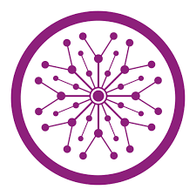

**Name: Ahsan Ali**

**Roll No: 061**

**Task: 10**

**Section: BSAI-4B**

**Subject: PAI Lab**

**Submitted To: Sir Rasikh**

**Title:**

**University Admission Chatbot**

**Objective:**

To develop a GUI-based chatbot application using Flask as the backend framework and HTML/CSS for the frontend. The chatbot will answer university admission-related queries and simulate a simple conversational interface.

**Tools & Technologies Used:**

| **Technology** | **Purpose** |
| --- | --- |
| Python | Programming language |
| Flask | Web framework (backend) |
| HTML | Frontend structure |
| CSS | UI styling and design |
| JavaScript | Client-side interaction |

**Functional Requirements:**

* Accepts user input via GUI.
* Processes input on the Flask backend.
* Returns chatbot response to the user.
* Supports basic predefined questions like:
  + Admission process
  + Courses offered
  + Deadlines
  + Scholarships

**Project Structure:**

chatbot_app/

├── app.py # Flask backend

├── static/

│ └── style.css # CSS styles

└── templates/

└── index.html # Frontend

**How It Works:**

1. The user enters a question in the chatbot input box.
2. JavaScript sends the message to Flask using a POST request.
3. Flask matches the message to predefined responses.
4. The reply is sent back and shown in the chat window.

**Sample Questions the Bot Understands:**

| **User Question** |  |  | **Bot Response** |
| --- | --- | --- | --- |
| Hello |  |  | Hello! How can I assist you with university admissions? |
| admission process |  |  | Visit our portal and fill the admission form. |
| courses |  |  | We offer B.Tech, MBA, BBA, and more. |
| scholarship |  |  | Yes, we offer merit-based scholarships. |
| deadline |  |  | Last date is June 15, 2025. |
| thank you / bye |  |  | You're welcome! / Goodbye and best of luck! |

**Code:**

from flask import Flask, render_template, request, jsonify

app = Flask(__name__)

responses = {

    "hello": "Hello! How can I assist you with university admissions?",

    "hi": "Hi there! Ask me anything about courses, deadlines, or procedures.",

    "admission process": "To apply, please visit our admissions portal and fill the form.",

    "deadline": "The last date to apply is June 15, 2025.",

    "courses": "We offer B.Tech, MBA, BSc, BBA, and many other programs.",

    "scholarship": "Yes, we provide merit-based scholarships.",

    "thank you": "You're welcome! Feel free to ask more.",

    "bye": "Goodbye! All the best for your admission."

}

@app.route("/")

def index():

    return render_template("index.html")

@app.route("/get", methods=["POST"])

def get_bot_response():

    user_msg = request.form["msg"].lower()

    for key in responses:

        if key in user_msg:

            return jsonify({"reply": responses[key]})

    return jsonify({"reply": "Sorry, I didn't understand that. Please ask something else."})

if __name__ == "__main__":

    app.run(debug=True)

**User Interface Screenshot:**

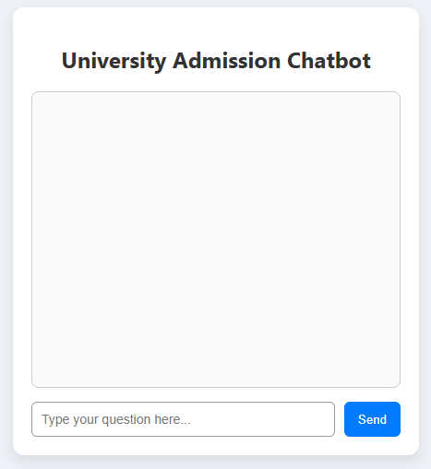

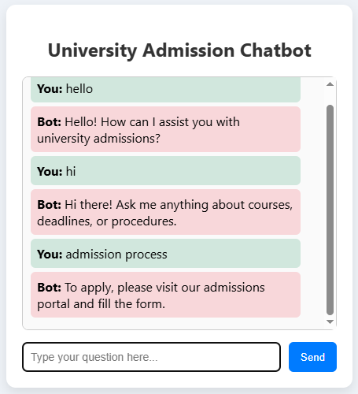

**Conclusion:**

This project demonstrates how a simple chatbot can be built using Flask and HTML/CSS. It provides basic question-answer functionality and serves as a foundation for building more advanced AI-driven bots in future work.